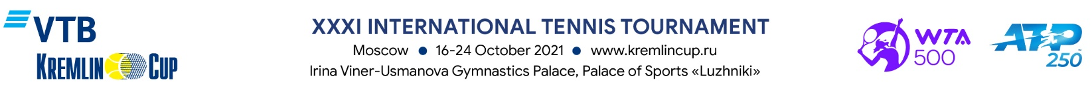

ACCREDITATION FORM

MEDIA (Registration Certificate):
Surname: |  |  | Name:
Address:
Mobile phone: |  |  | E-mail:

Type of Media:

Print Media

Radio

Information Agency

Internet

Blog

TV*

Other (specify)

Job Title:

Correspondent Operator Other (specify)

Editor TV* TV (Technical Staff)

* TV companies should provide additional information to get accreditation.

ATTENTION: in light of the ongoing COVID-19 pandemic, all application requests are for access to a Virtual Media Centre through which media may cover the tournament remotely. Depending on the epidemiological situation ahead of the tournament, the Organizing Committee might send personal invitations with access to the media centre at the stadium to a limited number of media representatives who have applied for virtual access.

To get accreditation fill in all the fields in the Form, attach a scanned copy of the Company letter (pdf) and a photo (preferably 300 dpi, jpg, 4x6 cm), as well as of the current year publications dedicated to ATP and WTA tournaments, Davis Cup, Billie Jean King Cup, Tokyo Olympic Tennis tournament.

All applications must be submitted by October 4, 2021, to the following e-mail address: media@russport.ru. Applications submitted after the deadline and applications from the representatives of advertising agencies will not be accepted.

Tournament Organizing Committee reserves the right to deny accreditation without explanation.

If your Application for Accreditation is approved, you will receive a confirmation to your e-mail address.

Approval of the Head

_______________________________________________________________________________________
Signature of the Director and Stamp Date

